Andre Hardy – Project 12-6

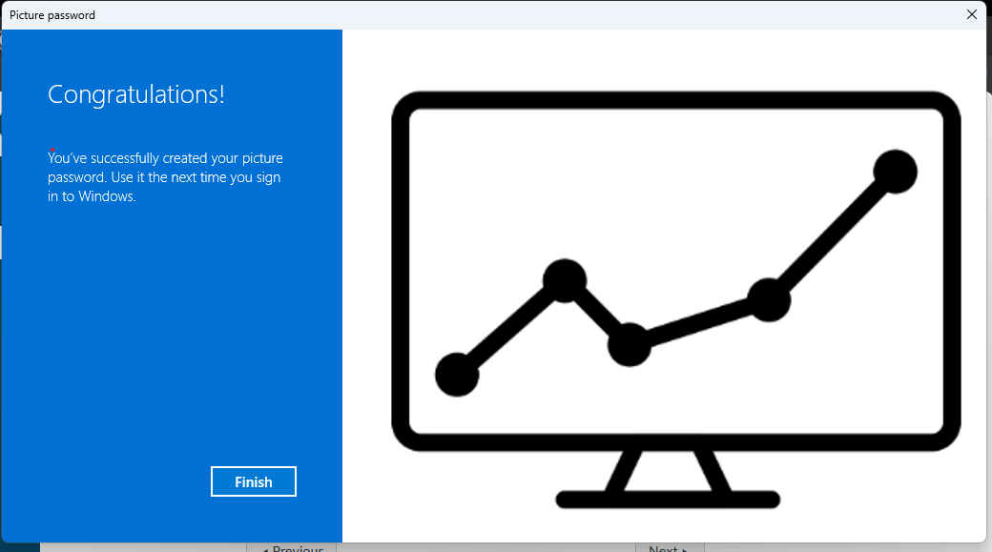

18. How easy is picture password to use? how difficult? Would you consider it more or less secure than a password? Why?
A: It is fairly simple to use, although it reminds me of a pattern passcode. It seems more secure than a password because it would not be cracked with conventional or common tools.

